**Refractory failure in kiln**

[**https://www.cementequipment.org/main-category/kiln-section/kiln-refractories/everything-you-need-to-know-about-cement-kiln-refractories/**](https://www.cementequipment.org/main-category/kiln-section/kiln-refractories/everything-you-need-to-know-about-cement-kiln-refractories/)

Refractory, or the lining utilized on the interior of rotary kilns, is a critical component in ensuring process efficiency and prolonging the life of a rotary kiln

Rotary kilns employ high temperatures to cause a chemical reaction or physical change in a material. In most cases, these high operating temperatures would immediately destroy an unprotected carbon steel shell. For this reason, refractory is used in Kiln.

There is two type of kiln.

**castable and brick,**

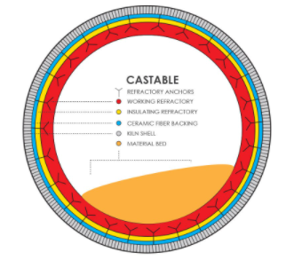 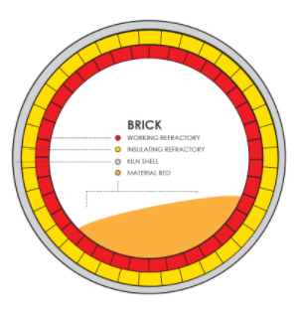

**Causes**

Cycling and chemical incompatibility are the two main causes of refractory failure in a rotary kiln.

##### **Cycling**

The biggest source of refractory failure is what is called *cycling*. Cycling is simply the heating up and cooling down of the rotary kiln. Each time the rotary kiln is heated, the refractory expands with the drum, and as the kiln is cooled, the refractory retracts. If a kiln is constantly being turned on and shut down, the refractory can easily become stressed, resulting in cracks.

Similarly, cracks can also occur from heating or cooling the kiln too quickly. To maximize refractory life, it is important to try to reduce cycling as much as possible, **keeping shut downs to a minimum.**

##### **Chemical Incompatibility**

Another common source of refractory failure is chemical incompatibility. Refractory is not designed to be able to withstand certain chemicals. A good example of this is chlorides.

Chlorides can aggressively attack refractory, causing excessive wear because of their corrosive nature. When these chemicals are identified up front, refractory can be designed with this in mind to help reduce the potential for excessive wear. Similarly, unknown components in a material or a change in feedstock can also result in excessive wear on refractory.

The maximum surface temperature of the cylinder should be kept below 380 ℃, and the maximum temperature should not exceed 415 ℃. Otherwise, the strength of the steel plate of the cylinder will be significantly reduced, causing cracking and other risks.

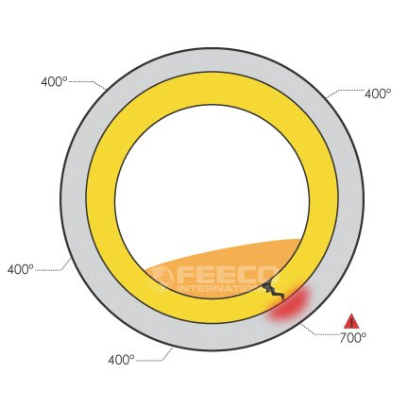

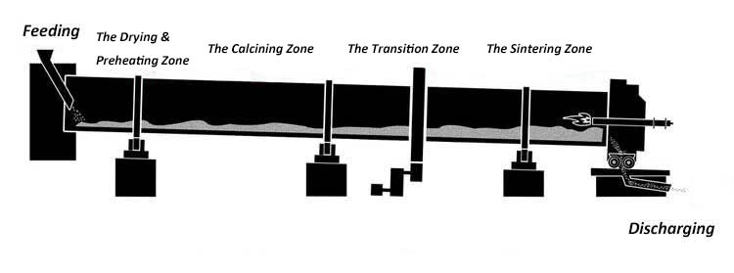

Sintering Zone - Check for leakage in steam which results in product leakage to fracture

Drying Zone - temperature maintained 200c

Firing Zone - 800c

Sintering stage: 1200oC

**Solution**

We need to maintain chemical incompatibility while feeding into kiln.

A camera set up can be used to get the scanned signal from an image. Image will have all the temperatures in the body.

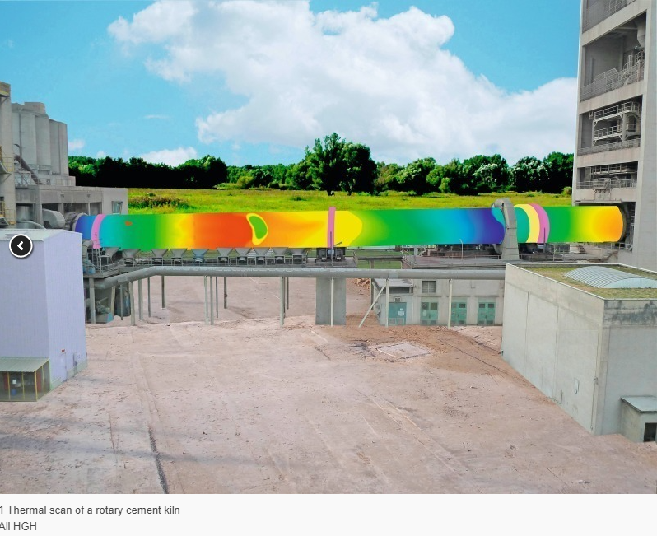

Images helps us to identify body temperature.

Historical data management of all relevant parameters, such as temperature profile, brick and coating thickness, Chemical profile ,kiln speed and tyre slip allows the maintenance manager to get a clear overview of the kiln status and trends in a centralized dashboard.

With this data the operator can decrease the shell distortion by adjusting the flame and rotation speed to adapt burning conditions. Efficient shell distortion monitoring also results in avoiding hot spots.

**Benefits**

**No breakdown or failure caused any production interruption** and the two kiln scans are functioning smoothly and reliably. The plant employees and management report that the kiln monitoring system is easy to use and that the images are very clear and precise.